# Lab: DOM Introduction

Submit your solutions in the SoftUni judge system at:

[DOM Introduction - Lab - SoftUni Judge](https://judge.softuni.org/Contests/Practice/Index/2760#0)

**Environment Specifics**

Please, be aware that every JS environment may **behave differently** when executing code. Certain things that work in the browser are not supported in **Node.js**, which is the environment used by **Judge**.

The following actions are **NOT** supported:

* **.forEach()** with **NodeList** (returned by **querySelector()** and **querySelectorAll()**)
* **.forEach()** with **HTMLCollection** (returned by **getElementsByClassName()** and **element.children**)
* Using the **spread-operator** (**...**) to convert a **NodeList** into an array
* **append()** in Judge (use only **appendChild()**)
* **prepend()**
* **replaceWith()**
* **replaceAll()**
* **closest()**
* **replaceChildren()**
* Always turn the collection into a **JS array** (forEach, forOf, et.)

If you want to perform these operations, you may use **Array.from()** to first convert the collection into an array.

## Edit Element

Create function **edit()** that takes **three** parameters.

### Input / Output

**The first** parameter is a **reference** to an **HTML** element, the other two parameters are string–**match** and **replacer.**

You have to **replace** all occurrences of the **match** inside the **text content** of the given element with a **replacer.**

### Examples

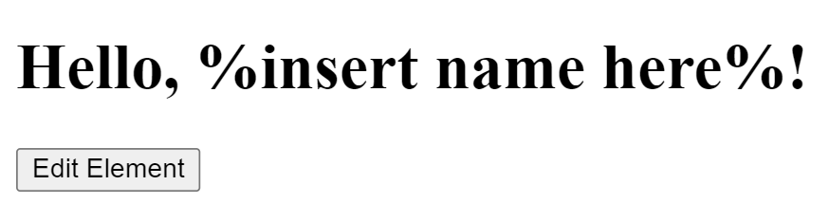

**↓**

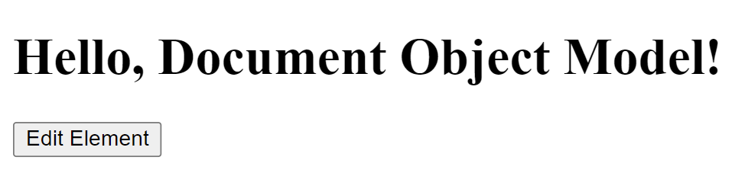

## Collect List Items

Write a JS function that scans a given **HTML list** and **appends** all collected list items’ text to a **textarea** on the same page when the user **clicks** on a button.

### Input / Output

There will be no Input / Output, your program should instead **modify** the DOM of the given HTML document.

### Examples

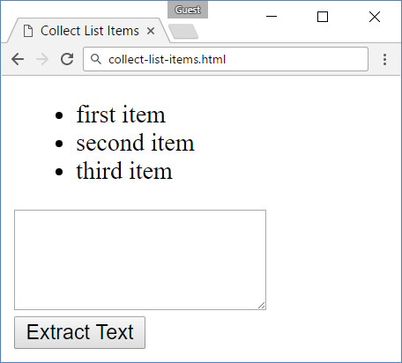 🡪 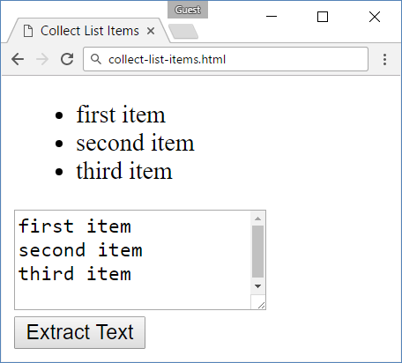

1. **Sum Numbers**

Write a JS function that **reads** two numbers from input fields in a **web page** and puts their **sum in another field** when the user **clicks** on a button.

**Input / Output**

There will be no Input / Output, your program should instead **modify** the DOM of the given HTML document.

**Examples**

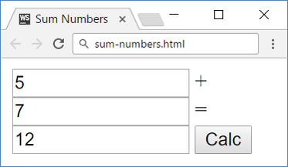

## Show More

Write a JS function that **expands** a hidden section of text when a link is **clicked**. The link should **disappear** as the rest of the text shows up.

### Input / Output

There will be no Input / Output, your program should instead **modify** the DOM of the given HTML document.

### Examples



**↓**



## Colorize Table

Write a JS function that **changes the color** of all **even** rows when the user **clicks** a button. Apply the color "**Teal**" to the target rows.

### Input / Output

There will be no Input / Output, your program should instead **modify** the DOM of the given HTML document.

### Examples

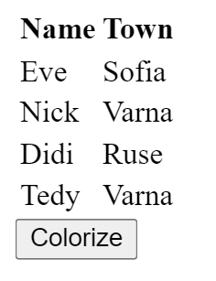 🡪 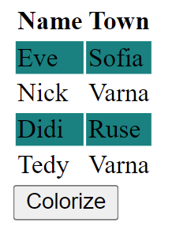

## Sum Table

Write a JS function that finds the first table in a document and sums the values in the last column. The result is then displayed in an element with ID "**sum**".

### Input / Output

There will be no Input / Output, your program should instead **modify** the DOM of the given HTML document.

### Examples

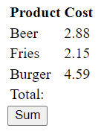 **→** 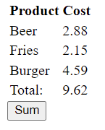

## Extract Parenthesis

Write a JS function that when **executed**, extracts all parenthesized text from a target paragraph by given element ID. The result is a string, joined by "; " (semicolon, space).

### Input

Your function will receive a **string parameter**, representing the target element ID, from which text must be extracted. The text should be extracted from the DOM.

### Output

**Return a string** with all matched text, separated by "; " (semicolon, space).

### Examples

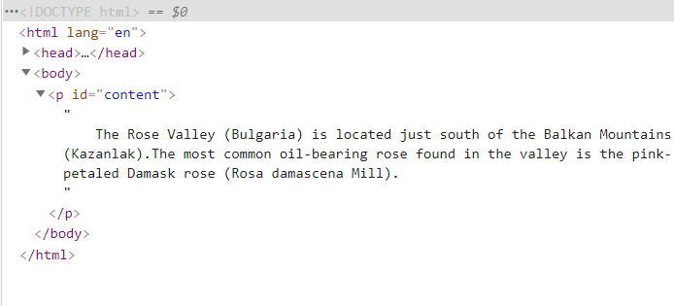

|  |
| --- |
| **Sample call** |
| let text = extract("content"); |
| **Result (stored in variable text)** |
| Bulgaria; Kazanlak; Rosa demascena Mill |